Create Contest – Module Test
Section 1 :
Contest Name : Done Contest Category : Done Game Category : Done
Filter Category : Done Loyalty Point : Not working.
Confirm Contest : Done Auto Create : Done Default Contest : Done
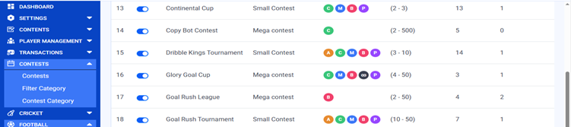
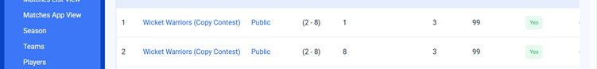
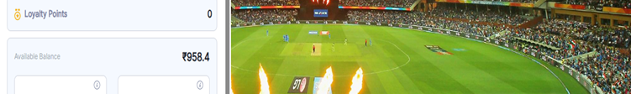Section 2 :
Multiple Entry : Done Cashback Enabled – Done
Yes – Checked Min No of team for cashback : Done Cash back amount : Done
No – Checked Cashback Type : Done
Team Join Limit : Done
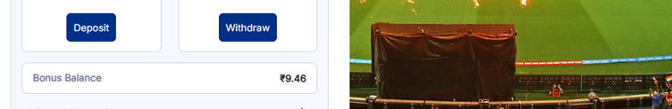
Section 3 :
Min Entry – Done Max Entry – Done Entry Fee – Done
Total Payout – Done, Bonus util (%) – Done,
Winner’s count – Error sometime ( https://photos.app.goo.gl/BonGvqA7RmHG4WP96 )
Status : Done
Active – Checked , IN – Active – Checked
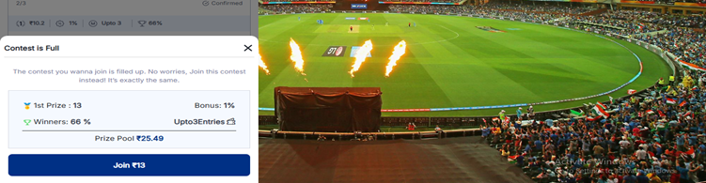

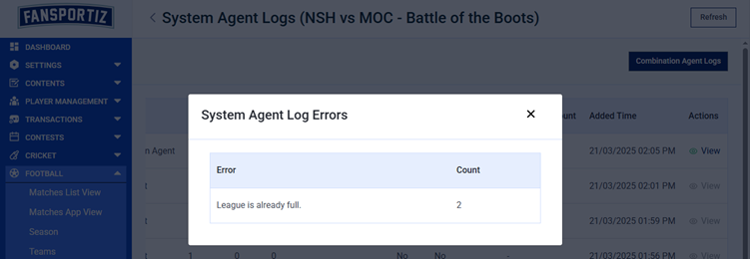
Section 4 :
Pool Prize : Done Unlimited Join? : Done
Yes – Checked Yes – Checked
No – Checked No – Checked

Section 5 :
Agent Create: Yes – Done, No – Done
Min No of Team for Agent : Done ( Accepted minus value )
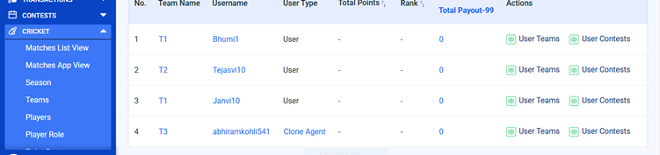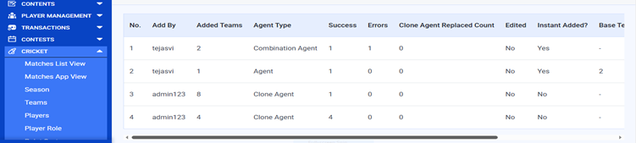

Contest Prize break ups:
Edit Button : Not Working ( https://photos.app.goo.gl/5ku12CZ9i35VzAvv6d9 )
Delete Button : Not Working ( https://photos.app.goo.gl/SZR8uPiRpJpm8pSM9 )

Contest Add to any match :
Football and Cricket : Done
Contest Names :
1. Football : Goal Rush Tournament, Glory Goal Cup, Battle of the Boots, Thunder Cup, The Goal Masters, Dribble Kings Tournament, Champions Clash, Continental Cup.

2. Cricket : Stump Strikers League, Legends Of Pitch,Wicket Warriors.
Edit Match Details :
Match Status : Done
Pending / Upcoming/Live/ In- review/Completed/ Cancel
Prize Distribution : Done
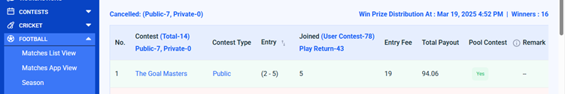
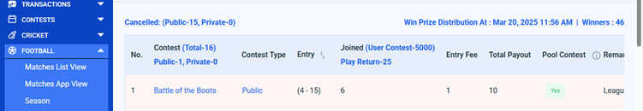
Bonus : Done
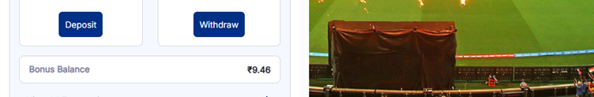
Amount : Done
